Structure of Professional Schools

Applied Project Final Report

By

Ziyue Liu

Spring 2022

A paper submitted in partial fulfillment of the requirements for the degree of

Master of Science in Management and Systems

at the

Division of Programs in Business

School of Professional Studies

New York University

***Table of Contents***

Declaration 4

Acknowledgements 5

Abstract 6

Abbreviations and Definitions 7

Introduction 8

Problem Description and Opportunity 9

Project Objectives and Metrics 10

Alternate Solutions Evaluated 11

Approach and Methodology 13

Results 15

Risk Analysis 26

Issues Encountered 27

Project Chronology and Critique 28

Lessons Learned 29

Conclusion and Summary 30

Limitations, Recommendations and Scope for Future Work 32

Literature Survey 33

References 39

Appendix A - Project Acceptance Document 39

Appendix B - Project Sponsor Agreement 41

Appendix C - Project Charter 47

Appendix D - Project Plan 52

Appendix E - Risk Management Plan 53

Appendix F - Status Report 56

Appendix G - Annotated Bibliography 59

# Declaration

I, Ziyue Liu, declare that this project report submitted by me to School of Professional Studies, New York University in partial fulfillment of the requirement for the award of the degree of Master of Science in Management and Systems is a record of project work carried out be me under the guidance of Dr. Andres Fortino, NYU Clinical Assistant Professor of Management and Systems. I grant powers of discretion to the Division of Programs in Business, School of Professional Studies, and New York University to allow this report to be copied in part or in full without further reference to me. The permission covers only copies made for study purposes or for inclusion in Division of Programs in Business, School of Professional Studies, and New York University research publications, subject to normal conditions of acknowledgment. I further declare that the work reported in this project has not been submitted and will not be submitted, either in part or in full, for the award of any other degree or diploma in this institute or any other institute or university.

# Acknowledgements

I sincerely thank Dr. Andres Fortino for his contribution as sponsor of this project and as mentor during this project. I also want to thank all the instructors in the Management and Systems program who I have taken courses with and learned a great deal.

# Abstract

The purpose of this study is to Research and document the organizational structure of Schools of Professional Studies across multiple universities. Analyze their program offering to discover trends. Document the teaching of the management discipline and compare it to traditional schools of management. USNEWS Top25 graduate business schools in the United States and their professional schools were studied in this project for the purpose of finding relationships between management schools and professional schools. All the information for both business schools and professional schools was collected from their official website. The Excel file was used to record information for these schools’ graduate and Ph.D. programs under management schools and professional schools including but not limited to rank, school name, degrees, and programs. Using tools in Excel like the Pivot table could help the study to better analyze all the information and data of these Top25 schools. The client Dr. Andres Fortino and any faculty members from the NYU curriculum department could use this Excel file to find the relationship and information for these schools. By using this dataset as a tool, the school could decide to encourage or discourage a program or degree with persuasive evidence. Pivot tables have been conducted by the client to answer the analytical questions raised by the client and showed reasonable results. The analysis of information and data collected in this study could improve university decision-making on how to offer professional education, whether encouraging or discouraging one program. All the data collected in this project have been uploaded to GitHub for future access.

# Abbreviations and Definitions

Abbreviations that used in the Excel file:

SOM: School of Management

SPS: School of Professional Studies

MS: Master of Science

MA: Master of Arts

ALM: Master of Liberal Arts

EMBA: Executive MBA

MMS: Master of Management Science

# Introduction

## Background information

To analyze information of public and non-profit accredit universities in order to compare the relationship between their business school and professional school. Which size of accredited universities are offering business schools and professional schools at the same time and what are the overlaps and exclusives of majors and degrees between business schools and professional schools within one university.

## Company Name

New York University Professional Schools of studies is a non-profit private school located in New York City. It provides high-quality various majors of undergraduate, graduate, and associate degrees such as Management of System, Integrated Marketing, Hotel and Tourism Management, Sport Management, and so on. Located at 7 E 12th st, NEW York, NY, 10003.

## Sponsor Information

The project sponsor is Dr. Andres Fortino, NYU Clinical Assistant Professor of Management and Systems.

# Problem Description and Opportunity

## Importance of the project

This project is to analyze information from public and non-profit accredit universities in order to compare the relationship between their business school and professional school with which size of accredited universities are offering business schools and professional schools at the same time and what are the overlaps and exclusives of majors and degrees between the business school and professional school within one university. This project would help to discover the relationship between public and non-profit accredited universities’ business schools and professional schools. By analyzing the information for graduate business schools and professional schools for Top25 graduate business schools, this project could develop a complete comparison between professional schools and business schools, in order to improve the university's decision-making on how to offer professional education. This program not only analyzes the analytical questions that have been asked but more questions about professional schools and business schools can be answered, even about doctoral programs. Since the data from this project has been uploaded and is available for public use, anyone, including school curriculum departments, can use the data from this project to analyze the relationship between the top 25 graduate business schools and their professional schools as a reference to draw conclusions about how they should set their schools’ curriculum.

# Project Objectives and Metrics

## Goal of the project

The goal of the project was to analyze information from public and non-profit accredit universities in order to compare the relationship between their business school and professional school. Which size of accredited universities are offering business schools and professional schools at the same time and what are the overlaps and exclusives of majors and degrees between business schools and professional schools within one university.

## Project Deliverables and Metrics

Project Objective 1 – Requirement specification (February 1st)

* + Provide client requirement specification include project introduction, project details, and deadlines.

Metric: Client approvement (accepted by the client)

Project Objective 2 – Preliminary Database (March 1st)

* + Provide client the set of databases include basic information of accredit universities.

Metric: Client acceptance of completeness of the database.

Project Objective 3 – Preliminary analysis (April 1st)

* + have clear results of major/degree differences between professional schools and business schools.

Metric: All the answers for the questions are accepted by the client.

Project Objective 4 – Conclusion (May 1st)

* + Generate conclusion with final result for the project

Metric: acceptance by client.

**Project Evaluation**

Project success was evaluated by ….

1. Project schedule

*All the deliverables are delivered and got approved by the client on time.*

*1st deliverable- requirement specification will be delivered to the client by February 1st.*

*2nd deliverable- preliminary database will be delivered to the client by March 1st.*

*3rd deliverable- preliminary analysis will be delivered to the client by April 1st.*

*4th deliverable- conclusion will be delivered to the client by May 1st.*

1. Project weekly status report and dashboard

*A Gantt chart with all the progress and milestones is provided, any weekly updates of the project is shown on the Gantt chart. Meanwhile, every week’s meeting with the client will report the update, improvement, and difficulty of the project to the client.*

1. Project communication plan, issues log, risk register

*Every Friday is scheduled a 30min to 1 hour’s meeting with the client. During the meeting, all the conversations will be recorded, and meeting notes are taken by Zoey, in case any important requirement are necessary. In the beginning of every week’s meeting, Zoey will ask questions and give updates to the client based on the meeting notes.*

1. Project status reports

*Project status will be reported once a week, include difficulties, changes, and progress.*

# Alternate Solutions Evaluated

## Solution Evaluation Criteria

Based on whether my client could use the Excel database to do analytical analysis to answer the questions they come up with.

## Selection Rationale

The ultimate goal of this project is for my client to use the data that I compiled from the top 25 graduate business schools and their professional schools to make the data analysis he wants and draw conclusions to answer the various analytical questions he mentioned. As long as these questions can be analyzed and answered using various Excel tools, then the database created by this project is usable and valid. Since my data is newly collected, it can be used by users to perform the data analysis they want at any time. Also, being able to answer my client’s questions means that my project has produced an Excel spreadsheet that includes all the information my client needs, so this evaluation criterion can be used as an alternate solution evaluation criteria.

# Approach and Methodology

In the first place, we planned to look for all accredited schools that are public or private schools with over 4000 enrolled undergraduate and graduate students. When we did the research on AASCB and IPEDs, we could barely find information that fit the client’s needs. I downloaded the completed data provided on IPEDs, but they cannot classify different schools’ with majors for each university, which is an important category our research will conduct. They only provide information for the whole university with their majors and enrollments. I cleaned the data with that information but could hardly find the data we need. All the majors shown in this database were in CIPCODE format, so I matched each major with CIPCODE. However, even though the majors are cleaned and listed in the file, they were still hard to classify as management schools and professional schools. After my client and I discussed the main analytical questions we want to do the research we finally decide to only focus on USNEWS listed Top25 graduate business schools. These 25 universities are all accredited schools and have business/management schools. I used the list on USNEWS and researched their official websites for their business/management schools and professional schools. With each business/management school, I looked through their MBA, EMBA, MS, MA, Ph.D., joint programs, and dual degrees, in case I missed any program or degree they offer. After gathering information from the business/management school, I researched professional schools. Not all universities have a professional school, so I have to be really careful. For each university, I research continuing education, continuing school, professional school, and professional education with each university’s name. For universities with professional schools, I did the same as business/management schools. I investigated their academic menu to see what kind of degrees and programs they offer. With all the information about schools, degrees, and programs I gathered from universities’ websites, I put all the data into the Excel file. My client has his analytical questions listed and used Excel tools like Pivot table to conduct necessary data analysis using the data I compiled during the semester. After the client approved the Excel file I created, I uploaded it to GitHub for future users to access.

# Results

## Repository of Data Sets and Code

The data sets created for this study may be found at:

## <https://github.com/ZoeyLiu3135/Top25/blob/7910ca2b2f75686b8e26e9f947a8e79cf91d43bf/TOP25%20Annotated.xlsx>

## Summary of Results

Here are the screenshots we got when we conducted Pivot Table in Excel for analytical questions that my clients come up with:

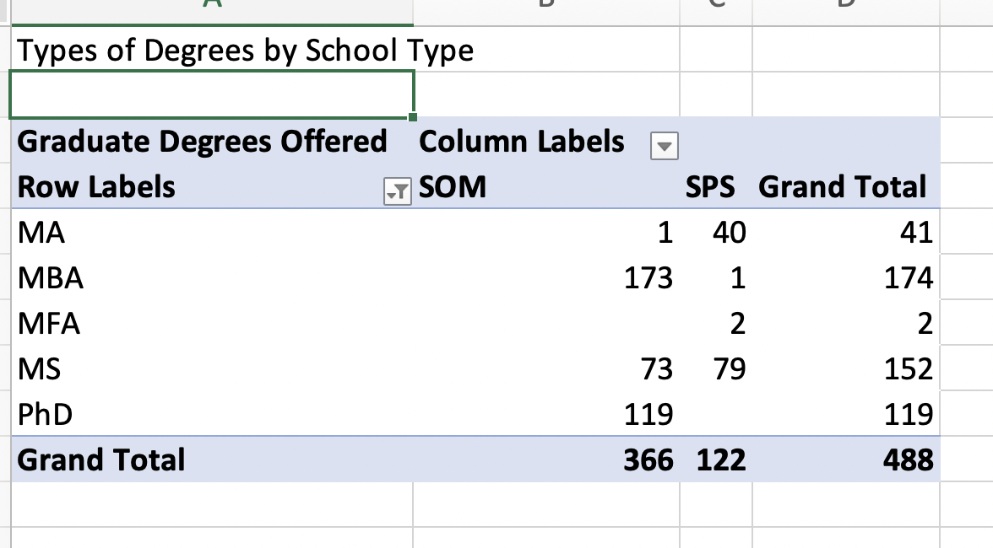

Figure1: Pivot table for how many degrees are offered by TOP25 graduate business schools and their professional schools.

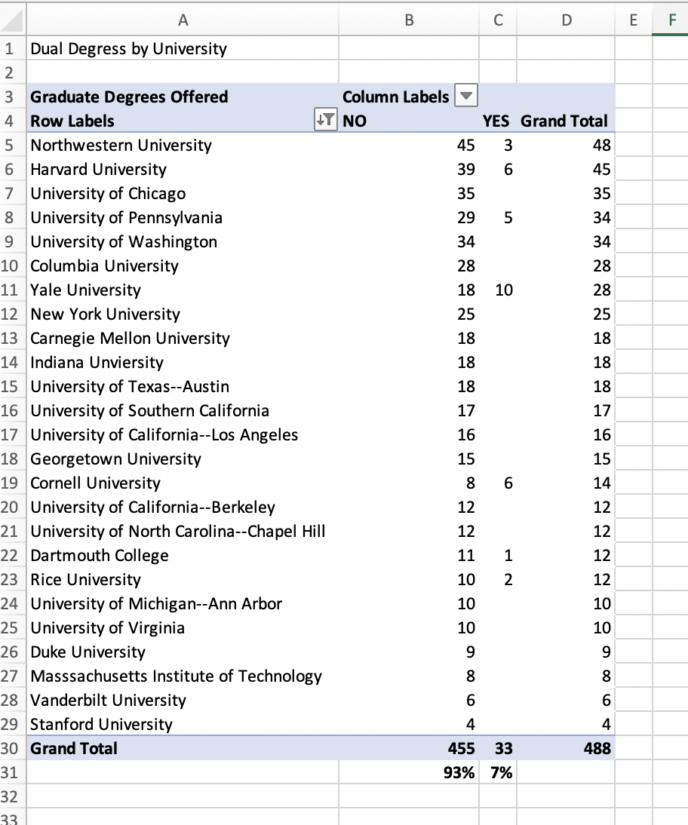

Figure2: Pivot table for which universities offer dual degree, and their percentage.

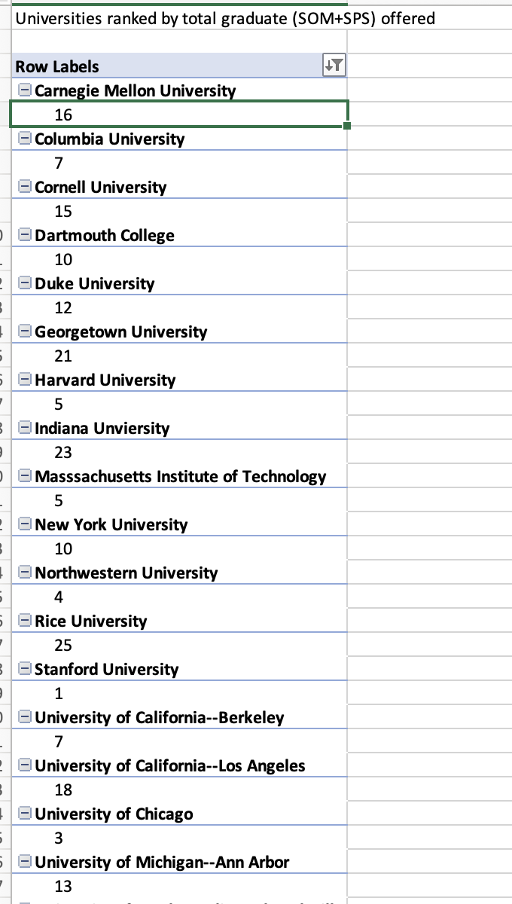

Figure3: Rank in Alphabetic sequence.

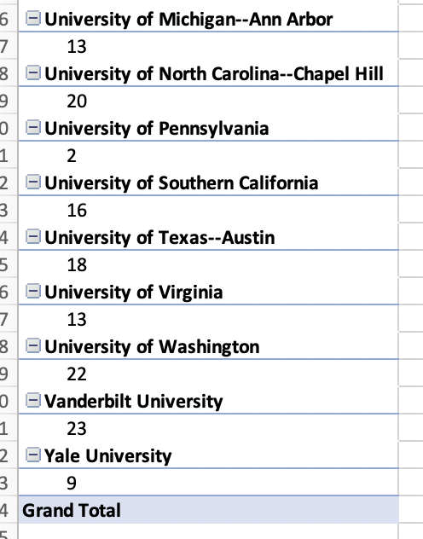

Figure3: Figure3: Rank in Alphabetic sequence(Continued)

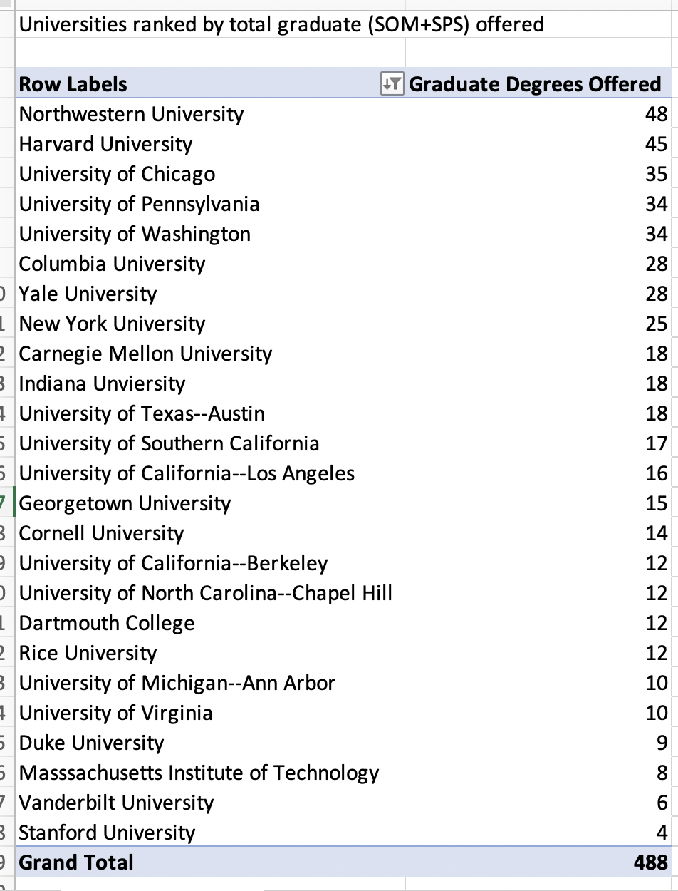Figure4: Pivot table for how many degrees are offered by each school.

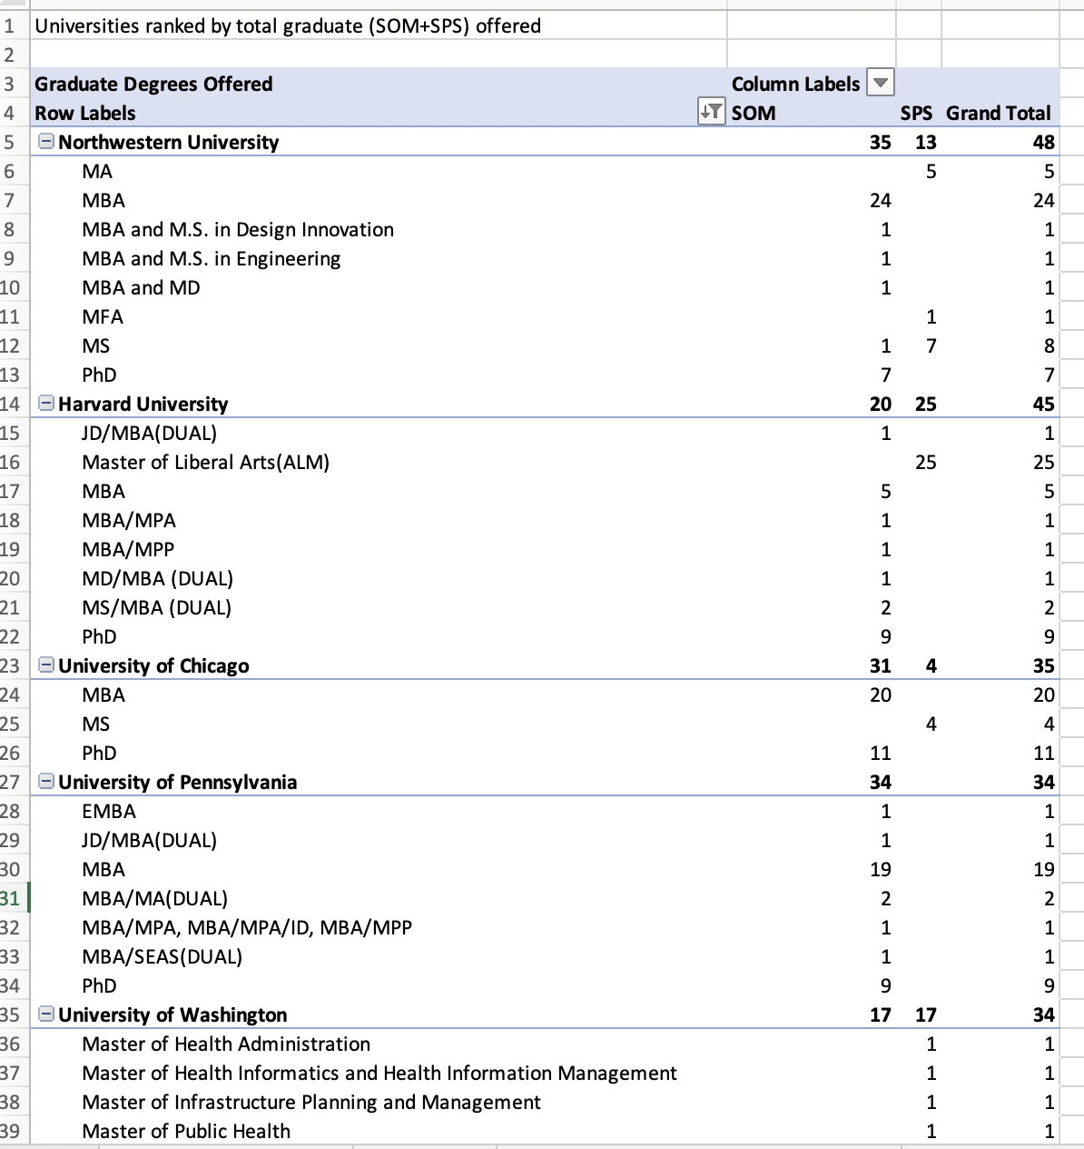Figure 5: Degrees are offered by each University.

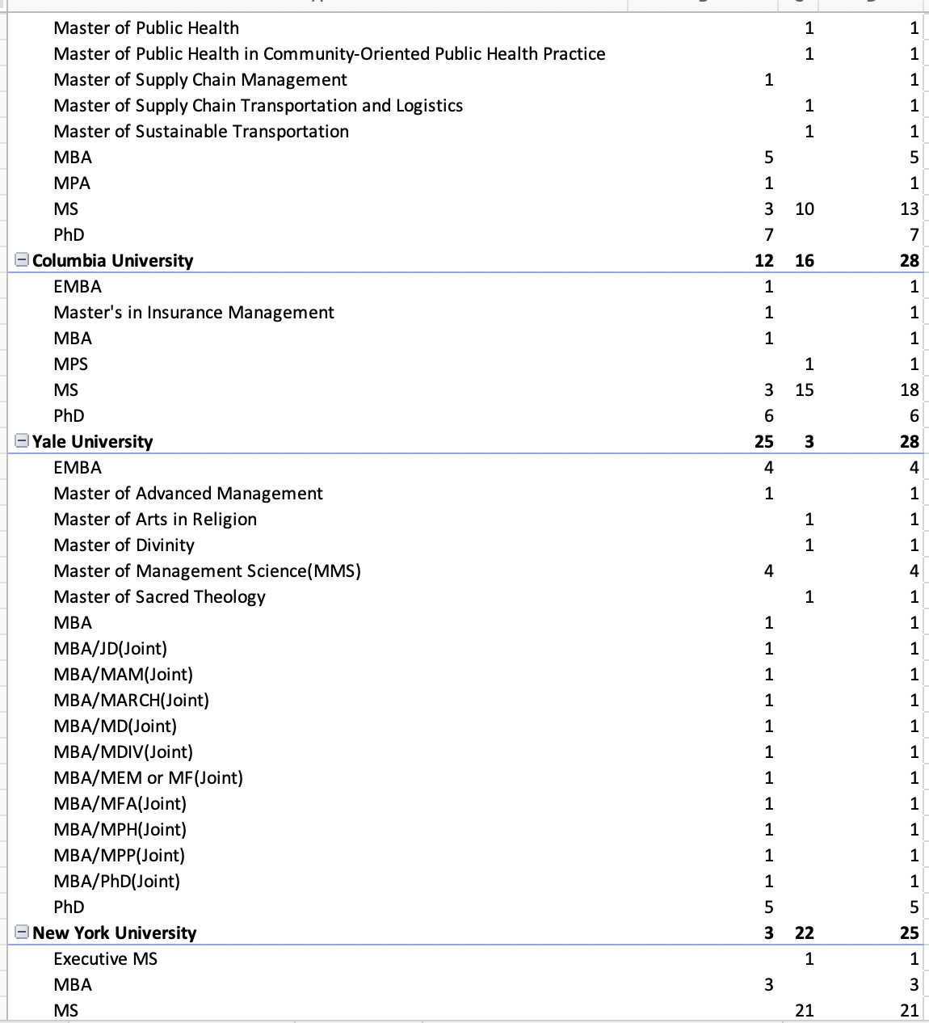Figure6: Degrees are offered by each University(Continued)

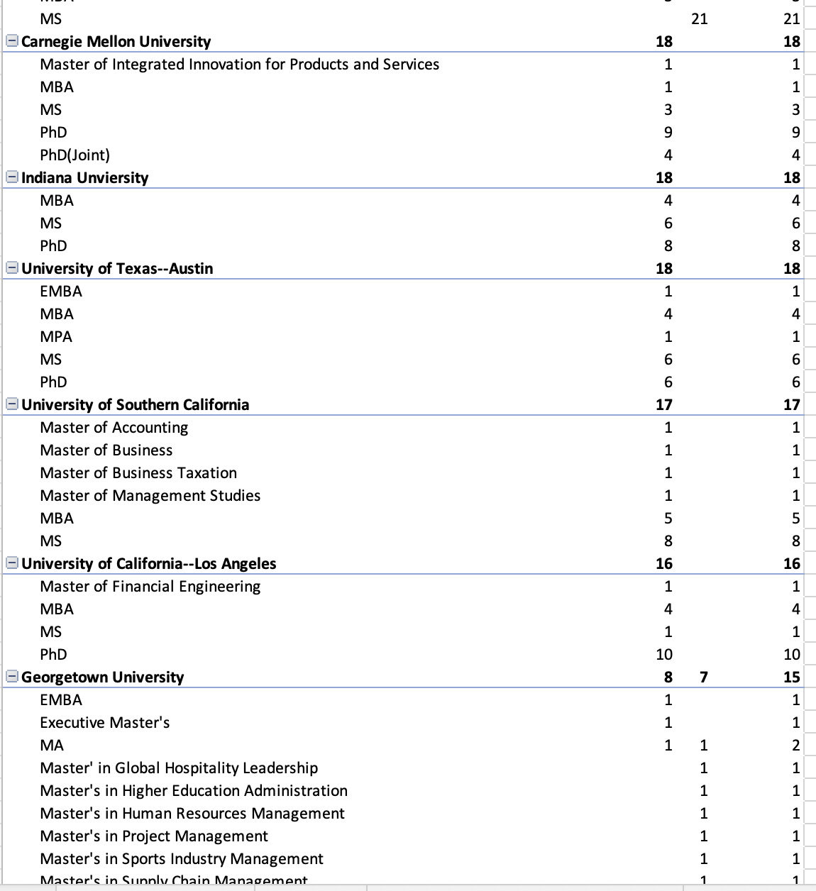 Figure7: Degrees are offered by each University (Continued2)

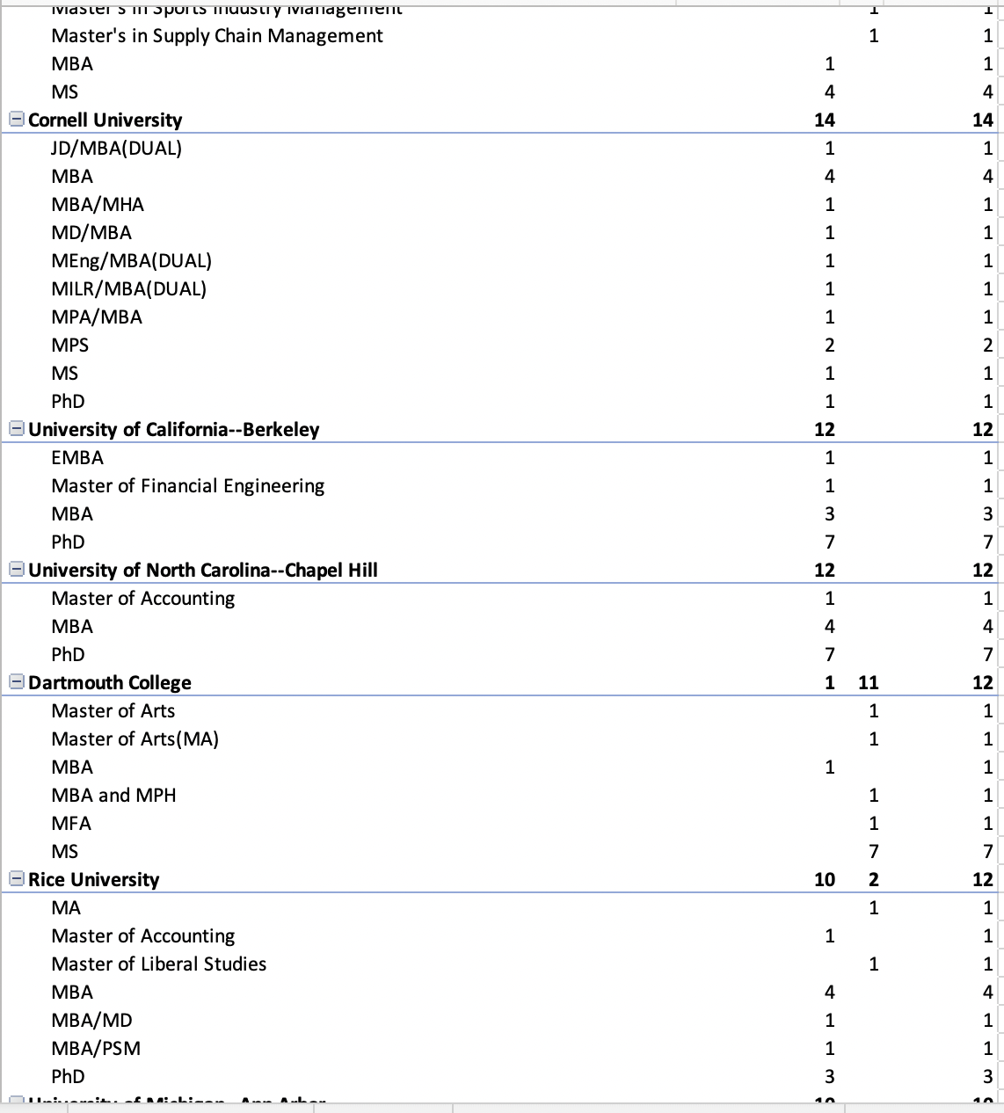 Figure8: Degrees are offered by each University (Continued3)

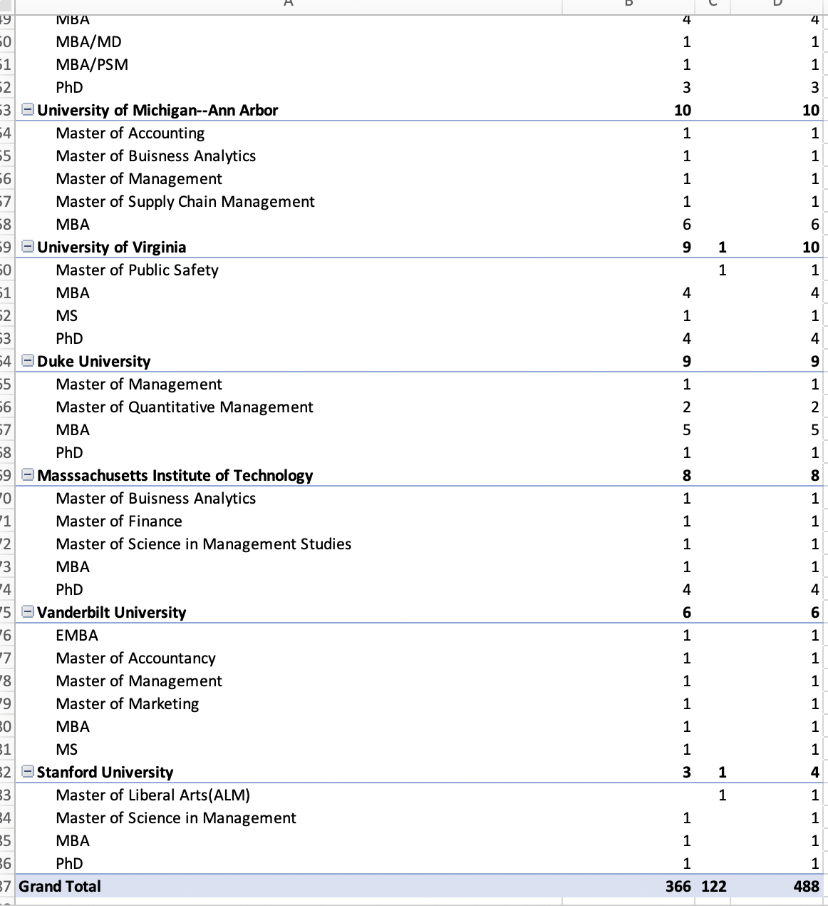

Figure9: Degrees are offered by each University (Finished)

Following is the brief screenshot for the dataset we generated and used for analytical questions.

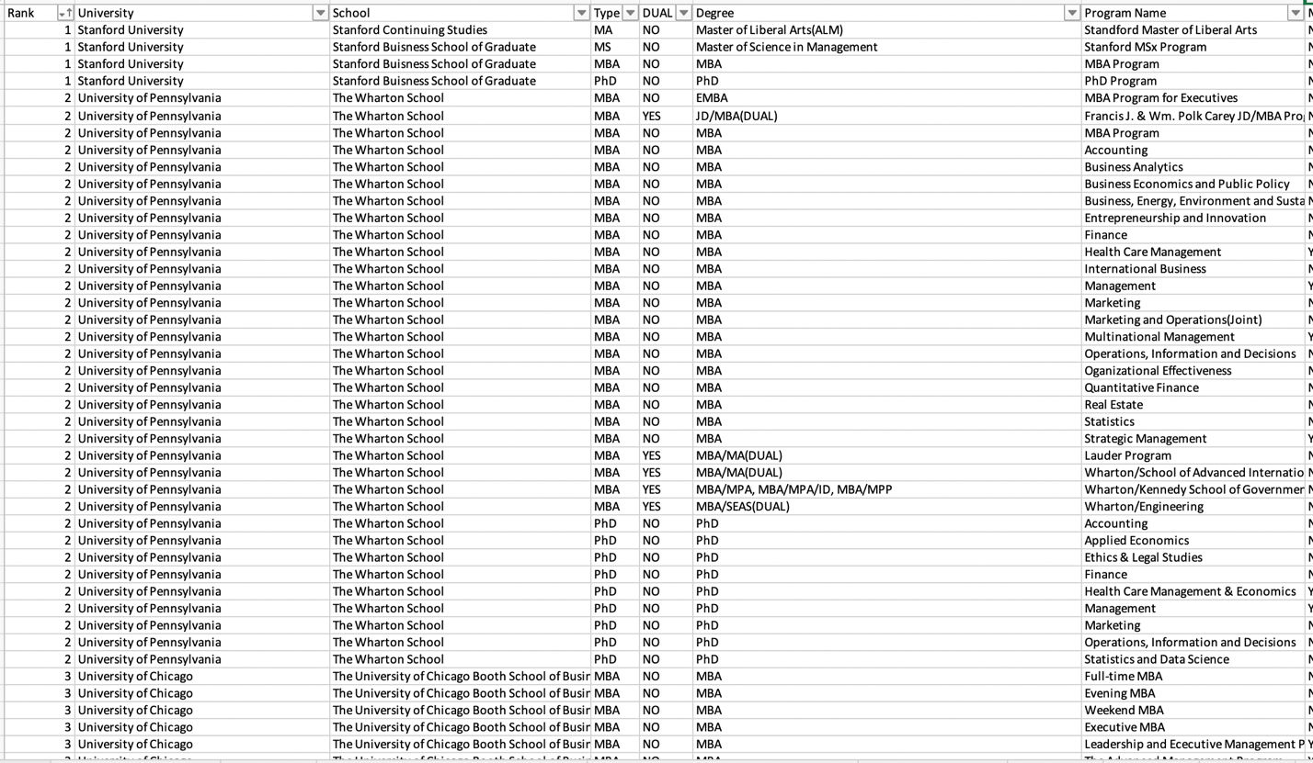

Figure10: Screenshot for the dataset of the project.

# Risk Analysis

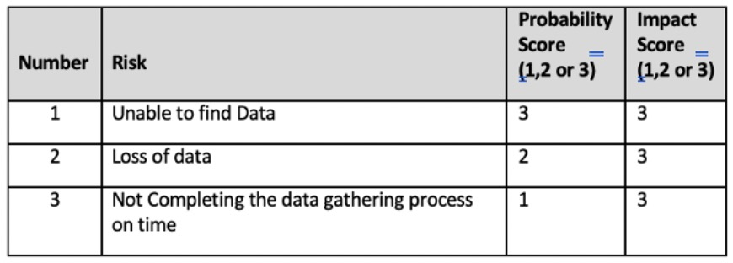

Figure 11: Risk Analysis table

In the planning process, I was worried about hard to find the data we need and this risk did happened when we were researching for useful date.

# Issues Encountered

While working on the project, I encountered some issues. All the issues the team faced are minor issues that do not have a major impact on the project. All issues were solved immediately once indicated so that the project was able to finish on time with high quality. Here is all type of issues the project team faced in the duration of the project.

The issue the team faced was unable to find the right database we could use. In the first place, we planned to look for accredited private or public universities with at least 4000 undergraduate and graduate enrollments. We did find a database that includes enrollment, majors, universities, and locations. However, all the majors were in CIPCODE format, and degrees, programs, and schools were mixed. It was unrealistic for us to classify each university’s schools with majors and degrees since there were over 24,0000 rows of data. Since the dataset missed essential elements that we need in the analytical process, we abandoned that dataset and tried to figure out another way to do the project. This issue was the largest trouble we encountered during our process of research. Finally, in the discussion with my client, we decide to change our data resource to only TOP25 USNEWS listed graduate business schools.

When listing this new dataset, we create the file from the blank. I tried to do the research for TOP25 graduate business schools’ majors, programs, and degrees on USNEWS official website, however the access to that information was locked for members only, so I used the rank list on USNEWS then use the University website to do the information collection by myself.

When did the new list, we were hard to decide whether we should put Ph.D. into the dataset or not. Then we decide to get Ph.D. information first, if later we found this information useless, we will then delete them.

# Project Chronology and Critique

During the process of gathering data, I found that if I could find more already existing datasets that include other information about these Top25 graduated business schools, my database would be more comprehensive. In my database, I only include rank, university name, degree, program name, and school type. If there were more databases available, I could probably include more, such as graduation rates, enrollment rates, admissions rates, etc. Although these contents are not requested by my client, if more information can be provided, then my client can do deeper data research through my database.

In addition, this project only collected information from Top25 graduate business schools, if more time and resources were available, information from Top50 or even Top100 graduate business schools could be collected to make the analysis results more convincing and credible. Of course, more data information means more challenging data cleaning steps. The hardest part of this project, besides collecting the data from each school from scratch, was the data cleaning that took up a large part of the time. Because all the information was typed manually, there were inevitably spelling errors and missing information, which could lead to serious errors in the final analysis of the questions. From there, we learned that if there was more time and effort available, a more comprehensive data cleanup should have been performed.

# Lessons Learned

The whole project was able to deliver as planned with expected quality and on time and this could not have been done without the contribution and help of all team members and the sponsor. During the whole project implementation, team members have learned by watching my client use pivot tables for data analysis to answer the questions he asked. No matter how detailed the data cleaning work is done in the early stage, the process of data analysis will always find some unreasonable and need to be improved, these changes will only be found in the process of data analysis, so I think, if possible, the person who collects the data had better pay attention to the whole process of data analysis, and timely data changes to meet the needs of the client.

Be sure to change data goals in a timely manner, if you find that the original task is impossible. Timely communication with the client can shorten the time being wasted. In the beginning, when deciding on the project goal, you did not do particularly detailed research, resulting in some needed data is not so easy to get, so in the process of searching, once you find the issue, you should communicate with the client in time to try to see if you can change the direction of the data to get the best performance.

Always mitigate the risks.

# Conclusion and Summary

This project focus on the Top 25 graduate business schools and their professional school’s information that provided on their official website. All the information was collected and cleaned carefully for analytical question use.

Analytical questions answered by this project’s dataset not limited to:

1. Descriptive statistics of the graduate degrees offered by the schools (type of degree, count by type of degree, clustering by academic discipline)

How many schools offer MBA/EMBA/MBA related?

1. Descriptive statistics of associated Schools of Professional Studies at these institutions (like the characteristics being compiled for the business schools).
2. Count of the names by which the schools are labeled: Schools of Management, Schools or businesses, Schools of Management and business, and Schools of professional studies, Schools have continued education, Schools of professional and continue education, for example as well as many other such titles.
3. An analysis of how to characterize a degree offering as to whether it is mostly academic preparation or professional preparation.
4. Analysis of the nature of the degree offering of Schools of Management as to how many of these degrees are professional preparation degrees versus academic degrees.
5. Analysis of the nature of the degree offering of Schools of Professional Studies as to how many of these degrees are professional preparation degrees versus academic degrees.
6. Analysis of the overlap in academic versus professional degrees offered by Schools of Management versus Schools of Professional Studies to determine how much of an overlap there is between these two units in their offerings, and to do it overall and by discipline.
7. A compilation and an analysis of which units offer the degree on a degree-by-degree basis. For example, which percentage of institutions have the MBA offered by the School of Management or the school of professional studies. What about for marketing master’s degrees? What about for degrees in management information systems? What about degrees and public relations? We should do this for the most popular degrees in each type of school, and on a discipline-by-discipline basis.

All the information and data that collected for this project was uploaded to GitHub, anyone interested in using this dataset to see the structure of professional schools and the relationship between business school and professional school for Top25 graduate business school in the United States could access the following link:

<https://github.com/ZoeyLiu3135/Top25/blob/7910ca2b2f75686b8e26e9f947a8e79cf91d43bf/TOP25%20Annotated.xlsx>

# Limitations, Recommendations and Scope for Future Work

Even though this project was able to deliver as expected, there are still some limitations within this project and some of the limitations may be improved in the future similar projects in NYU MASY.

First of all, only Top25 graduate business schools were included in the dataset, limited school amount means limited information that I could provide to the client. Even though my client is supporting the New York University which is included in the dataset. NYU SPS curriculum department faculties could use this database to conduct analyses for more convincing proposals about program settings. For future projects, Top50 -Top100 graduate business schools and their professional schools could be added to this database, and more columns beside rank, University name, degrees, programs, and school type.

In addition, a more careful data cleaning process could be conducted for the future project since in the process of my client conducting the pivot table, we found a couple of issues about the dataset which was not detected in the data cleaning process. With more school information will be added in the future project, a more careful data cleaning process should be conducted.

In the beginning of this project, since I did insufficient research about the accredited schools and their existing information, we found a limited dataset available open to the public. For better performance of such type research and data gathering process, more sufficient research for accredited universities should be done.

# Literature Survey

**Project Literature Review**

**Introduction**

Pursuing graduate school after undergraduate studies is a popular choice for many students before they are formally employed. There are many reasons to attend graduate school, including the desire to pursue more focused expertise that is not available in a graduate degree or to obtain better employment opportunities through a graduate degree. The choice between a business school and a college of continuing education is in large part due to the difference in programs offered by the different colleges and the degrees. The professional school, as a support for the business school, can meet the university's needs for a more niche business program, thus making the school's program more comprehensive and thus attracting more students to attend. Many students want to earn an MBA through graduate studies, but the specialization they want to pursue is not offered in business schools, which makes many students choose Professional Schools. Professional schools, as the name suggests, are schools that offer more specialized education, and many students who have worked for a short time find that they need more specialized knowledge in certain areas. After a short work experience, many students who have already worked find that they need more knowledge in certain areas of expertise, so they find a suitable program in the professional school to continue learning what they feel is lacking and to build a better foundation for their future work. For these students, professional school is more like a steppingstone to more specialized knowledge. Since some business schools only offer MBA programs, many specialized programs are only available in professional schools. As the demand for graduate degrees increases, more schools are offering more graduate programs to provide students with more career-ready degrees (Holtzman, S., Minott, T., Devasia, N., Kirova, D., & Klieger, D. ,2021). Many scholars have criticized business schools for not being adequately prepared to provide students to solve real-world problems (Lybeck, 2019) and lack engagement with the public (Chia & Holt, 2008; Nonet, Kassel, & Meijs, 2016). Business schools should adopt a value creation approach for their mutual benefit (Vargo & Lusch, 2004, 2008). Many of these real-world critiques have led to a decrease in trust in business schools as providers of management education (Murillo & Vallentin, 2016; Pettigrew & Starkey, 2016). The major and school a student chooses to attend after his or her undergraduate degree is influenced by many factors (Holtzman, S., Minott, T., Devasia, N., Kirova, D., & Klieger, D., 2021). Since business schools only offer limited graduate majors that do not meet the needs of students' employment specialties, many schools offer professional schools, a school that can offer more focused and specialized majors that provide students with more specialized knowledge (Copeland, M. T. 1958).

This study is to help the New York University School of Professional Studies curriculum department in improving their graduate curriculum by comparing to other management/business schools and professional schools’ degrees and programs. More people are choosing professional schools for their graduate degrees, so the curriculum should be more carefully tailored to the needs of the students. Students choose schools based on what kind of professional knowledge, skills, and future career development the school can provide, as the curriculum of professional schools and business schools are different. Research and document the organizational structure of Schools of Professional Studies across multiple universities. Analyze their program offering to discover trends. Document the teaching of the management discipline’s and compare to traditional schools of management. The goal is to analyze information of Top 25 public and non-profit accredit universities to compare the relationship between their business school and professional school. With which size of accredit universities are offering business school and professional school at the same time and what are the overlaps and exclusives of majors and degrees between business school and professional school within one university. The project is to discover the relationship between public and non-profit accredit universities’ business school and professional school. Meanwhile to develop a complete comparison between professional schools and business schools to improve university decision making of how to offer professional education.

New York University Professional Schools of studies is a non-profit private school located in New York City. It provides high quality various majors of undergraduate, graduate, and associate degrees such as Management of System, Integrated Marketing, Hotel and Tourism Management, Sport Management and so on. I will first look up for the list of qualified accredit universities and create a spreadsheet for future analyze. Then compare the majors and degree difference between each school’s business school and professional school. Difference will be displayed by percentage and clear data, when seeking for a result of comparison, the number will be easy to get from the data. Since the New York University is included in the TOP 25 business school list, this study will only focus on the US. NEWS TOP25 business schools and their professional schools (if they offer). After many research studies, academic reputation is consistently one of the important decision factors (Arpan et al., 2003; Maringe, 2006). Detailed information from top 25 accredit universities in US for their business school and professional school is required, including but not limited to majors, degrees, enrolled student size, locations. All information of each business school and professional school programs and degrees are retrieved from their official website to ensure the accuracy of data. All the data of business schools and professional schools are recorded in Microsoft Excel and analysis will be processed by tools in Excel including but not limited to VlookUp and diagram/chart generator. Without this study, current curriculum department decide the program settings based on their feedback from education experience and student feedback. The decisions are not necessarily accurate thought they are not based on sufficient database support. With this research dataset, the curriculum department could analysis questions based on the dataset and get a more comprehensive and persuasive decision.

## Conclusions

Due to the lack of professional programs that business schools could offer; Professional Schools are offering more professional majors that help students be more prepared for future employment. The most common response of business schools to improve professional ethics is to develop and implement courses in business and society and business ethics (Miller, 1967), however, for continuing schools or professional schools, the goal is to providing students’ preparation for more practical content and skills. Since many previous studies have focused on what is taught in business schools, few studies have addressed the curriculum of professional schools and the differences between teaching and learning in business schools. This study focuses more on the differences between the Top 25 US business schools and their professional schools in terms of their program offerings and the degrees they offer. Not all universities offer continuing education, and among those that do, the different curriculum and degrees allow the continuing schools to offer more precise and niche content for students to choose from. By organizing and analyzing the graduate degree programs of the School of Continuing Studies and the School of Business, we can better study the differences in curriculum and degree arrangements between the School of Business and the School of Continuing Studies of the same school, which will enable the NYU SPS curriculum department to better understand how other schools classify their programs and what kind of programs they offer, so that NYU students can have a more comprehensive selection of specialized studies in business graduate programs other than the MBA. This allows NYU students to be more selective and have a wider choice of specializations in graduate business programs beyond the MBA, such as real estate, marketing, project management, etc. Some of the programs offered at NYU SPS are offered at other schools in the School of Business, and this study will examine how many programs offered at other universities in the School of Business are offered at NYU SPS, thus allowing NYU SPS to offer a more comprehensive and attractive program of study. This study is to compile and analyze the differences in curriculum and degree between the top 25 business schools and their professional schools. Through the analysis, a more comprehensive program setting can be found, so that the program setting of the professional school can meet the needs of students more. From the researcher's point of view, this study is not limited to the access of NYU SPS curriculum department, but all the studied Top 25 business schools and their professional schools can use the database of this study to analyze the differences of their business schools and professional schools in terms of programs and degrees. The database will allow the study to analyze the differences in program placement and degrees between their business schools and professional schools to understand how certain programs better and more accurately are promoted or discouraged. Moreover, universities outside the top25 can use the examples of top25 schools to analyze the curriculum of their own business schools and professional schools for reference, to improve the curriculum of their own.

# References

Arpan, L. M., Raney, A. A., & Zivnuska, S. (2003). A cognitive approach to understanding university image. *Corporate Communications: An International Journal*, *8*(2), 97–113. https://doi.org/10.1108/1356328031047535

Chia, R., & Holt, R. (2008). The nature of knowledge in business schools. *Academy of Management Learning & Education*, *7*(4), 471–486. <https://doi.org/10.5465/amle.2008.35882188>

Copeland, M. T. (1958). *And Mark an era: The story of the Harvard Business School*. Little, Brown.

Holtzman, S., Minott, T., Devasia, N., Kirova, D., & Klieger, D. (2021). Exploring diversity in graduate and Professional School Applications. *ETS Research Report Series*, *2021*(1), 1–19. <https://doi.org/10.1002/ets2.12330>

Maringe, F. (2006). University and course choice. *International Journal of Educational Management*, *20*(6), 466–479. https://doi.org/10.1108/09513540610683711

Murillo, D., & Vallentin, S. (2015). The Business School’s right to operate: Responsibilization and resistance. *Journal of Business Ethics*, *136*(4), 743–757. <https://doi.org/10.1007/s10551-015-2872-1>

Miller, E. George (1967). Continuing Education for What? *University of Illinois College of Medicine, Chicago 60612* .

Vargo, S. L., & Lusch, R. F. (2004). Evolving to a new dominant logic for marketing. *Journal of Marketing*, *68*(1), 1–17. https://doi.org/10.1509/jmkg.68.1.1.24036

Vargo, S. L., & Lusch, R. F. (2008). Service dominant logic: continuing the evolution. Journal of the Academy of Marketing Science, 36: 1-10.

# Appendix A - Project Acceptance Document



Figure 12: Project Acceptance Document Page1.

Figure 13: Project Acceptance Document Page2.

# Appendix B - Project Sponsor Agreement

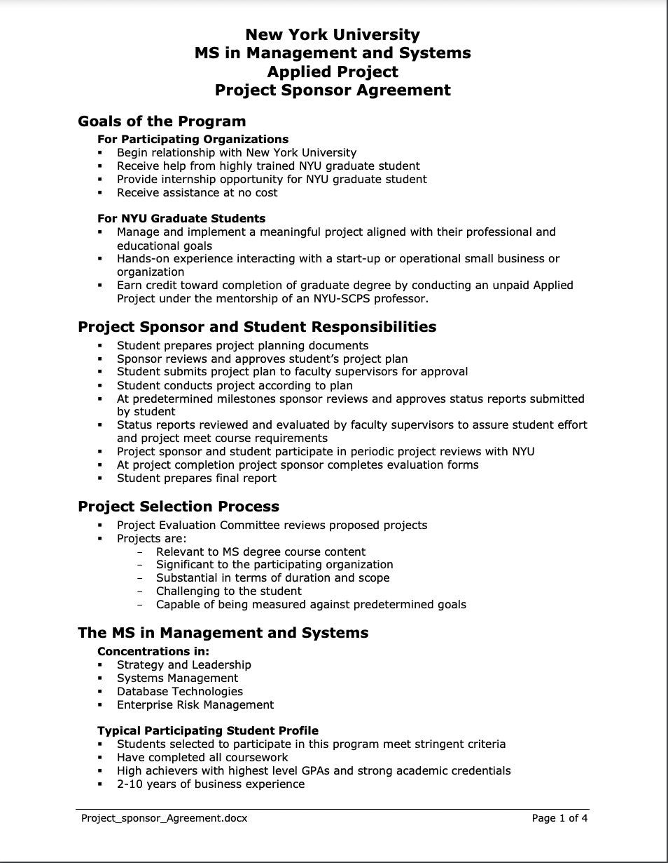

Figure 14: Project Sponsor Agreement Page 1.

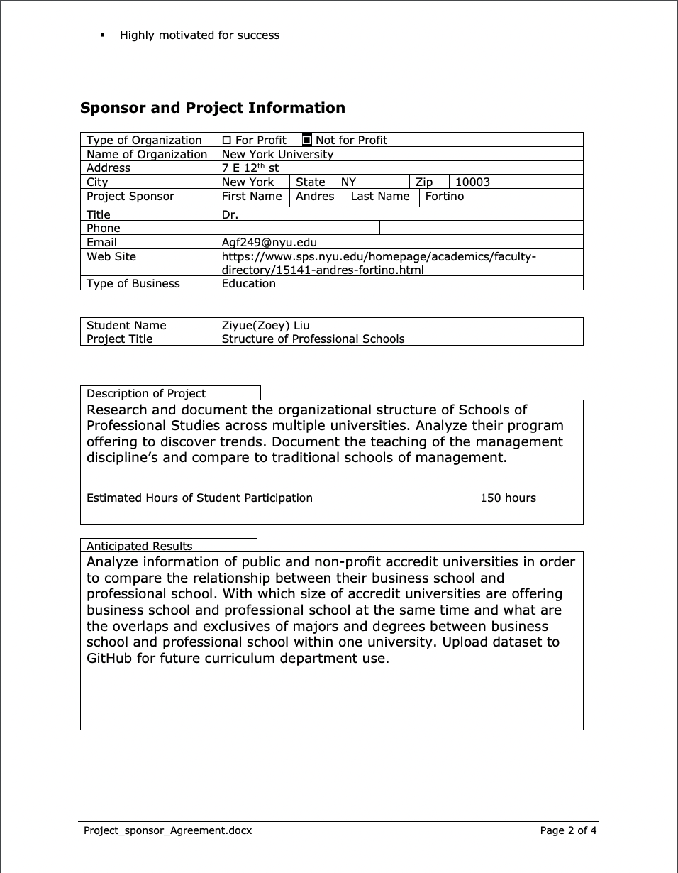

Figure 15: Project Sponsor Agreement Page 2.

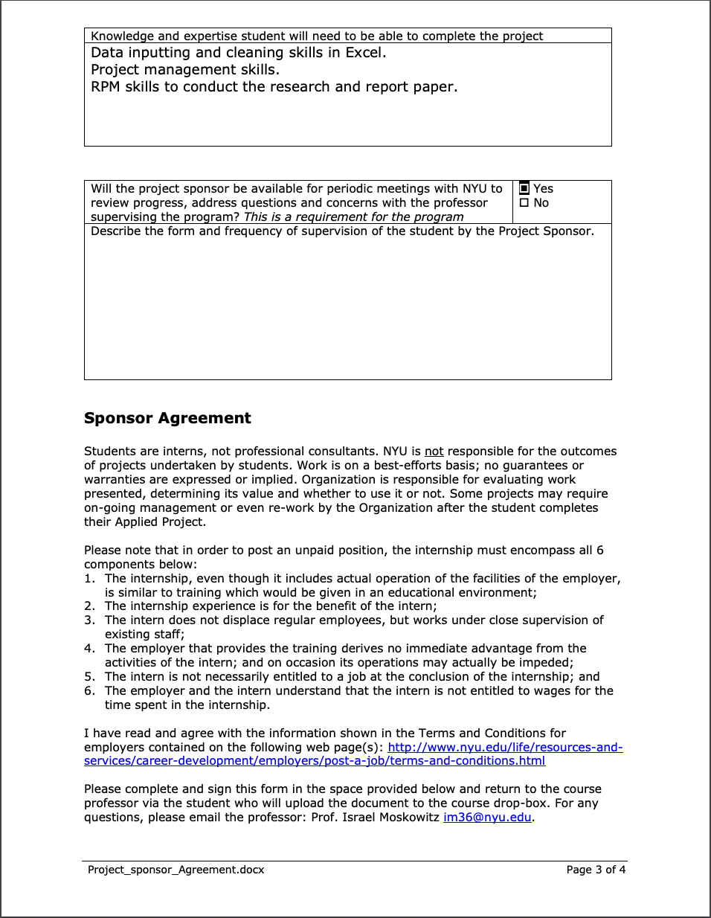

Figure 16: Project Sponsor Agreement Page 3.

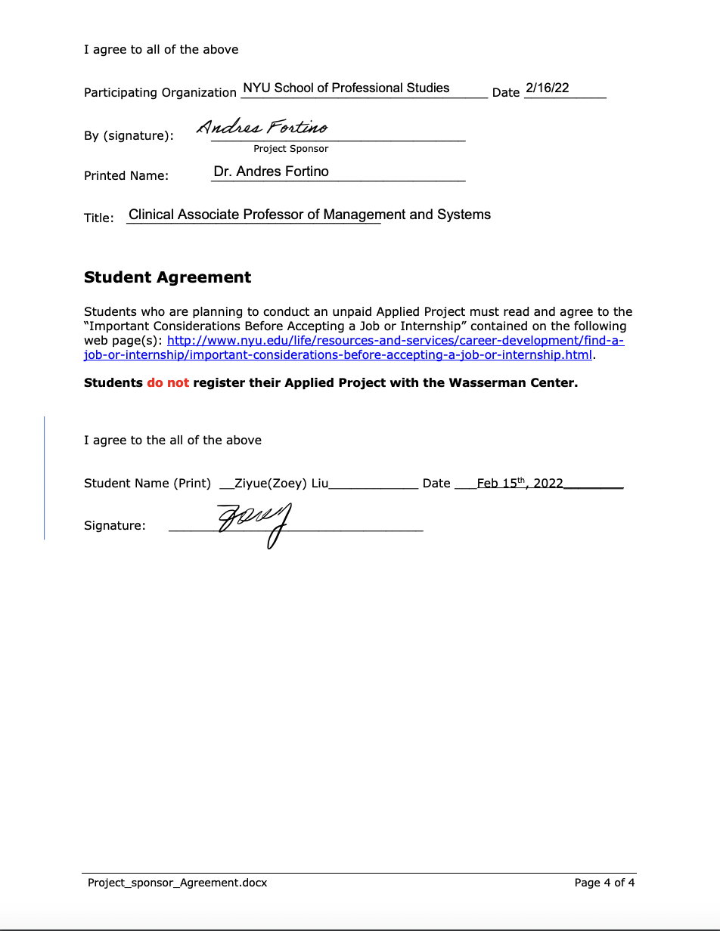

Figure 17: Project Sponsor Agreement Page 4.

# Appendix C - Project Charter

**Structure of Professional Schools**

**Project Charter**

Project Manager: *Ziyue (Zoey) Liu*

Sponsor: *Dr. Andres Fortino*

Prepared by: *Ziyue(Zoey) Liu*

Name and Location of Client Organization: *New York University, 7 E 12th st,New York, NY, 10003*

1. **Project Goal**

*To analyze information of public and non-profit accredit universities in order to compare the relationship between their business school and professional school. With which size of accredit universities are offering business school and professional school at the same time and what are the overlaps and exclusives of majors and degrees between business school and professional school within one university.*

1. **Problem/Opportunity Definition**

*Discover the relationship between public and non-profit accredit universities’ business school and professional school.*

*Develop a complete comparison between professional schools and business schools.*

*Improve university decision making of how to offer professional education.*

1. **Proposed Project Description**

*New York University Professional Schools of studies is a non-profit private school located in New York City. It provides high quality various majors of undergraduate, graduate, and associate degrees such as Management of System, Integrated Marketing, Hotel and Tourism Management, Sport Management and so on. I will first look up for the list of qualified accredit universities and create a spreadsheet for future analyze. Then compare the majors and degree difference between each school’s business school and professional school. Difference will be displayed by percentage and clear data, when seeking for a result of comparison, the number will be easy to get from the data.*

1. **Project Sponsor(s)**

Name and Title: Dr. Andres Fortino

Role within the organization: *Clinical Associate Professor of Management and Systems*

Role on the project: Sponsor

1. **Objectives**

*Objective 1 – Requirement specification (February 1st)*

* 1. *Provide client requirement specification include project introduction, project details, and deadlines.* 
     1. *Measurement: Client approvement (accepted by the client)*

*Objective 2- Preliminary Database (March 1st)*

* 1. *Provide client the set of databases include basic information of accredit universities.*
     1. *Measurement: client acceptance of completeness of the database.*

*Objective3- Preliminary analysis (April 1st)*

* 1. *have clear results of major/degree differences between professional schools and business schools.* 
     1. *Measurement: All the answers for the questions are accepted by the client.*

*Objective 4- Conclusion (May 1st)*

* 1. *Generate conclusion with final result for the project*
     1. *Measurement: acceptance by client.*

1. **Project Selection & Ranking Criteria**

Project benefit category:

|  |  |
| --- | --- |
| X | Compliance/Regulatory |
|  | Efficiency/Cost reduction |
|  | Revenue increase |

Portfolio fit and interdependencies

*This project is supporting the client’s understanding about the relationship between management schools and professional schools’ degrees and programs. By gathering and analyzing information of accredited universities’ management school and professional school’s program and degree, NYU SPS curriculum department could improve the efficiency and accuracy of future curriculum supporting and discouraging actions.*

Project urgency

*This project should be done as soon as possible since every semester NYU SPS curriculum department should decide which program should be discouraged or supported. By analyzing the data from other universities as soon as possible, NYU SPS curriculum department would be more efficient and reduce the cost of deciding curriculum settings.*

1. **Cost/Benefit Analysis**

Tangible Benefits

Benefit: No monetary benefit

Value & Probability: No immediate value

Assumptions Driving Value: None

Intangible Benefits

Benefit: Help NYU SPS curriculum department make more efficient and accurate decision of discouraging or encouraging the program.

Value & Probability: Help the curriculum department spend less time making decisions.

Assumptions Driving Value: Help and support NYU SPS curriculum department.

Cost Categories

Internal Labor hours: 150 hours

External costs: None

Labor: Contract Labor-Ziyue Liu

Equipment, hardware, or software: Excel

List other costs such as travel & training: None

Financial Return-None

1. **Assumptions**

*1.Project manager (Ziyue Liu) knows how to research data using all the resources that possible.*

*2.Project manager(Ziyue Liu) knows how to use Excel to gather, clean, and analysis data based on the client’s questions.*

*3. The client (Dr. Andres Fortino) will meet with the project manager(Ziyue Liu) every week to follow up the project progress.*

1. **Scope**

Quality

*The dataset of the project is consistent, UpToDate, and approved by the client.*

*The analysis result of the data is based on the question list the provided by the client.*

*All the deliverables are accepted by the client.*

Time

*1st deliverable- requirement specification will be delivered to the client by February 1st.*

*2nd deliverable- preliminary database will be delivered to the client by March 1st.*

*3rd deliverable- preliminary analysis will be delivered to the client by April 1st.*

*4th deliverable- conclusion will be delivered to the client by May 1st.*

Resource Allocation

*This project is assigned to Ziyue Liu only. All the data gathering, researching, and analyzing progress is processed on the Project Manager (Ziyue Liu)’s personal laptop.*

Out of scope activities

*For this project, the dataset is only used to be analyzed to answer the questions list that provided by the client. The dataset is agreed by the client, no more information or data content will be added after the dataset is done.*

Constraints

*1. The project manager’s skill level of Excel.*

*2. Analysis progress will only be processed in Excel.*

*3. Weekly meeting with the client via zoom.*

1. **Risks and Mitigation Strategies**

*1. Risk: inevitable schedule conflict to weekly meeting with the client; Mitigation Strategies: set up next available time for the meeting ASAP.*

*2. Risk: data lose; Mitigation Strategies: Back up all dataset in all stages.*

1. **Communications Plan**

1. *Every Friday 3:00pm-3:30pm from January 12th , 2022 to May 3rd, 2022.*

*2. Zoom Meeting.*

*3. Update of project progress; Project Q&A; Project deliverables approvement.*

1. **Schedule Overview**

Project Start Date: *Jan 12th, 2022.*

Estimated Project Completion Date: *May 3rd, 2022.*

Major Milestones:

*1st deliverable- requirement specification will be delivered to the client by February 1st.*

*2nd deliverable- preliminary database will be delivered to the client by March 1st.*

*3rd deliverable- preliminary analysis will be delivered to the client by April 1st.*

*4th deliverable- conclusion will be delivered to the client by May 1st*

External Milestones Affecting the Project: *None.*

1. **Impact of Late Delivery**

*If the 1st deliverable delayed, the project could not be started on time, and the client would not have a clear understanding of the project breakdowns.*

*If the 2nd deliverable delayed, the project’s analysis progress will be delayed. Without a completed and accurate dataset, all later deliverables will be postponed.*

*If the 3rd deliverable delayed, the project conclusion will not be gathered on time, and the 4th deliverable, conclusion, will not be presented to the client on time.*

1. **Resources Required**

Personnel:

|  |  |  |  |
| --- | --- | --- | --- |
| Role | Responsibilities | Duration of work | Qualifications needed |
| Project Manager | In charge of the whole project including research data, input data, data analysis, and generate conclusion. | 5 months | Excel skill, communication skill, RPM skill. |

Facilities, Software, Hardware and other Resources

*Excel, Word, PowerPoint.*

Procedures/ Methodology

*Excel- Vlookup.*

1. **Project Plan, Gantt**

*The Gantt Chart will show the project plan an attached accompanying document.*

*(See attachment on page6).*

1. **Project Evaluation**
2. Project schedule

*All the deliverables are delivered and got approved by the client on time.*

*1st deliverable- requirement specification will be delivered to the client by February 1st.*

*2nd deliverable- preliminary database will be delivered to the client by March 1st.*

*3rd deliverable- preliminary analysis will be delivered to the client by April 1st.*

*4th deliverable- conclusion will be delivered to the client by May 1st.*

1. Project weekly status report and dashboard

*A Gantt chart with all the progress and milestones is provided, any weekly updates of the project is shown on the Gantt chart. Meanwhile, every week’s meeting with the client will report the update, improvement, and difficulty of the project to the client.*

1. Project communication plan, issues log, risk register

*Every Friday is scheduled a 30min to 1 hour’s meeting with the client. During the meeting, all the conversations will be recorded, and meeting notes are taken by Zoey, in case any important requirement are necessary. In the beginning of every week’s meeting, Zoey will ask questions and give updates to the client based on the meeting notes.*

1. Project status reports

*Project status will be reported once a week, include difficulties, changes, and progress.*

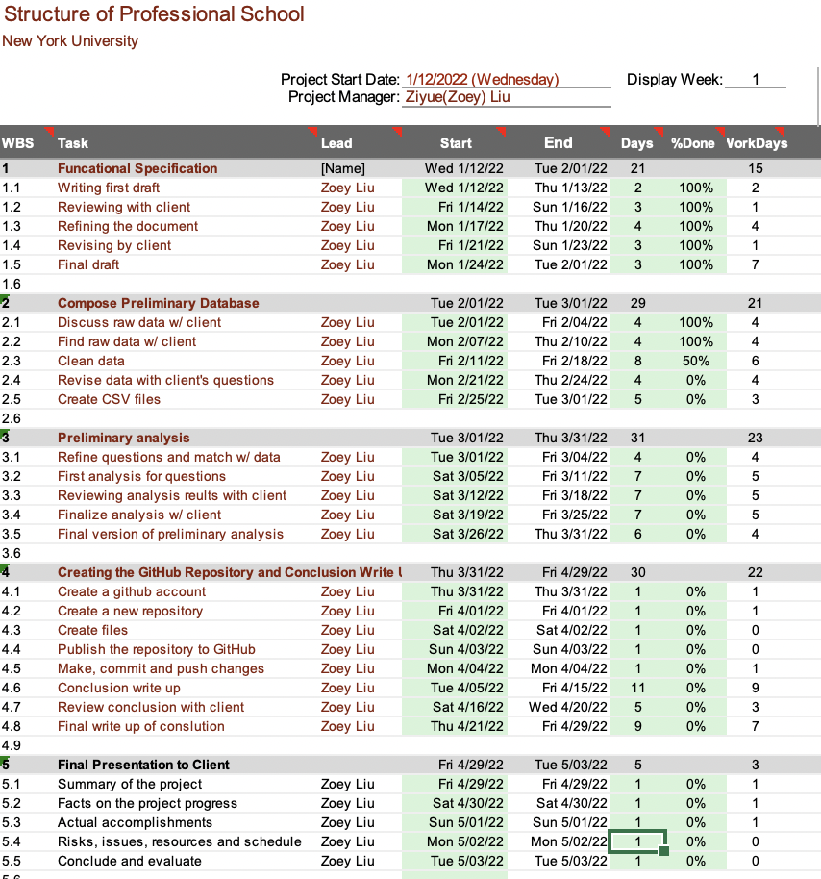

Figure 18: Gantt chart page 1.

# Appendix D - Project Plan

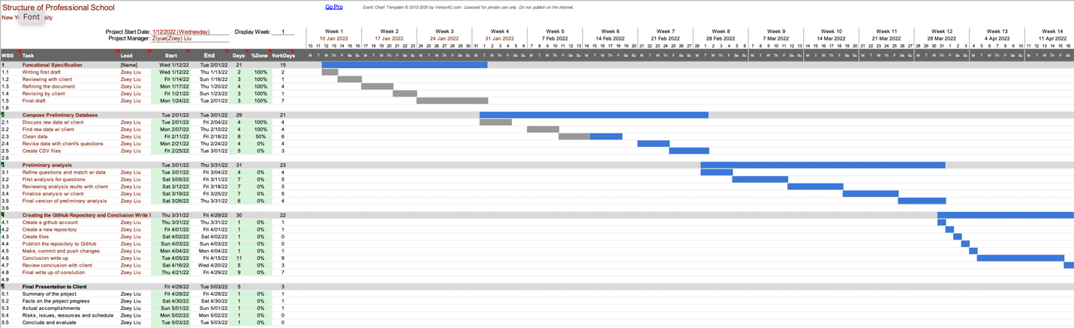

Figure 19: Project plan in weeks(Gantt Chart)

# Appendix E - Risk Management Plan

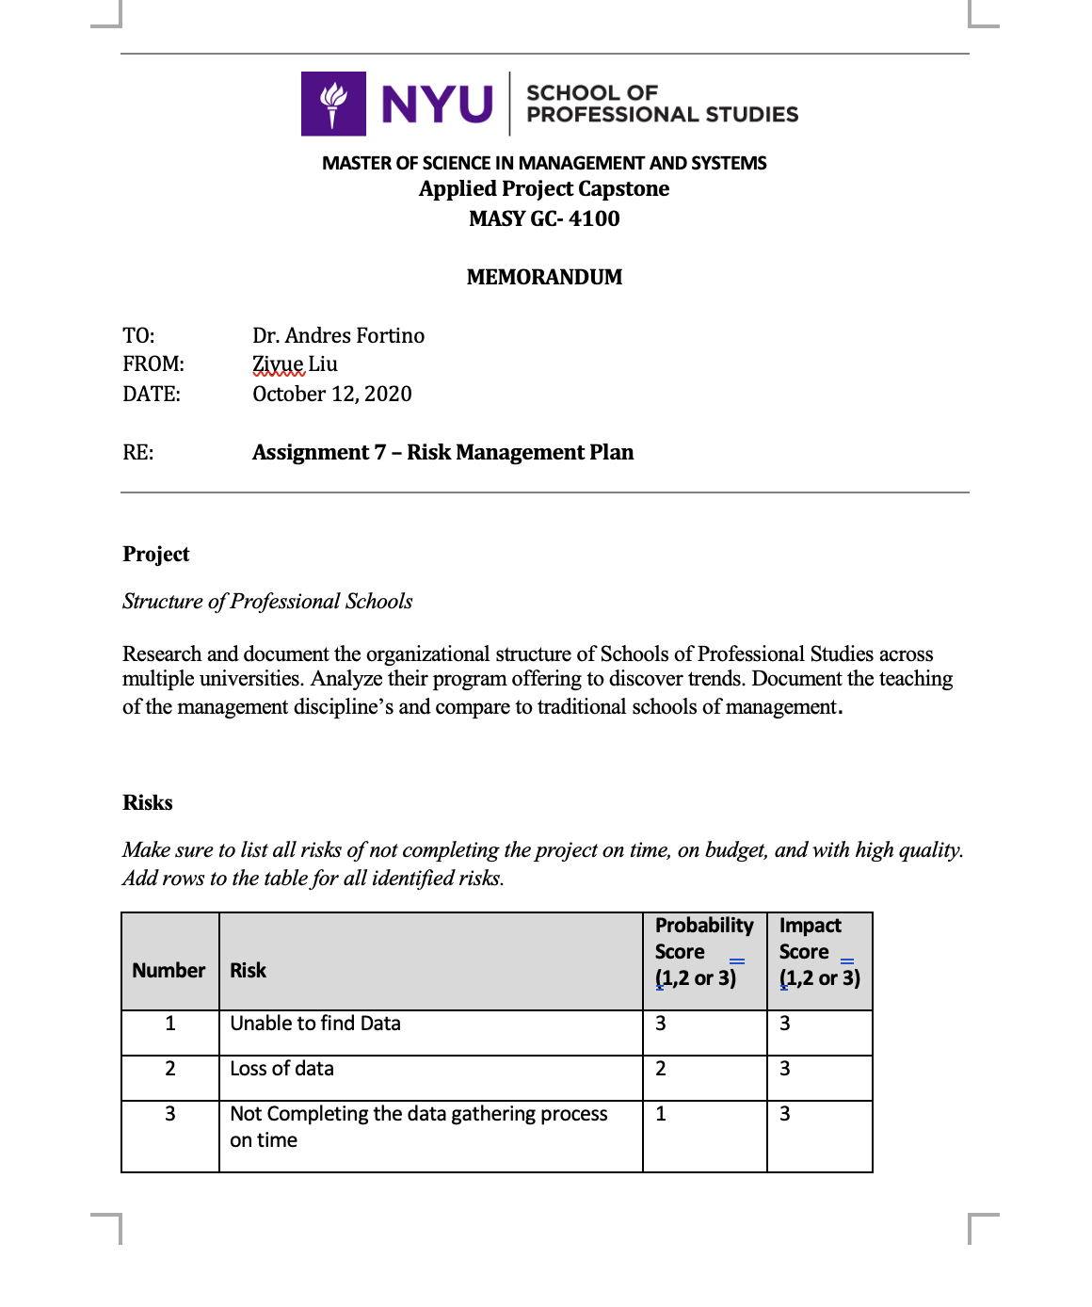

Figure 20: Risk Management Plan Page 1.

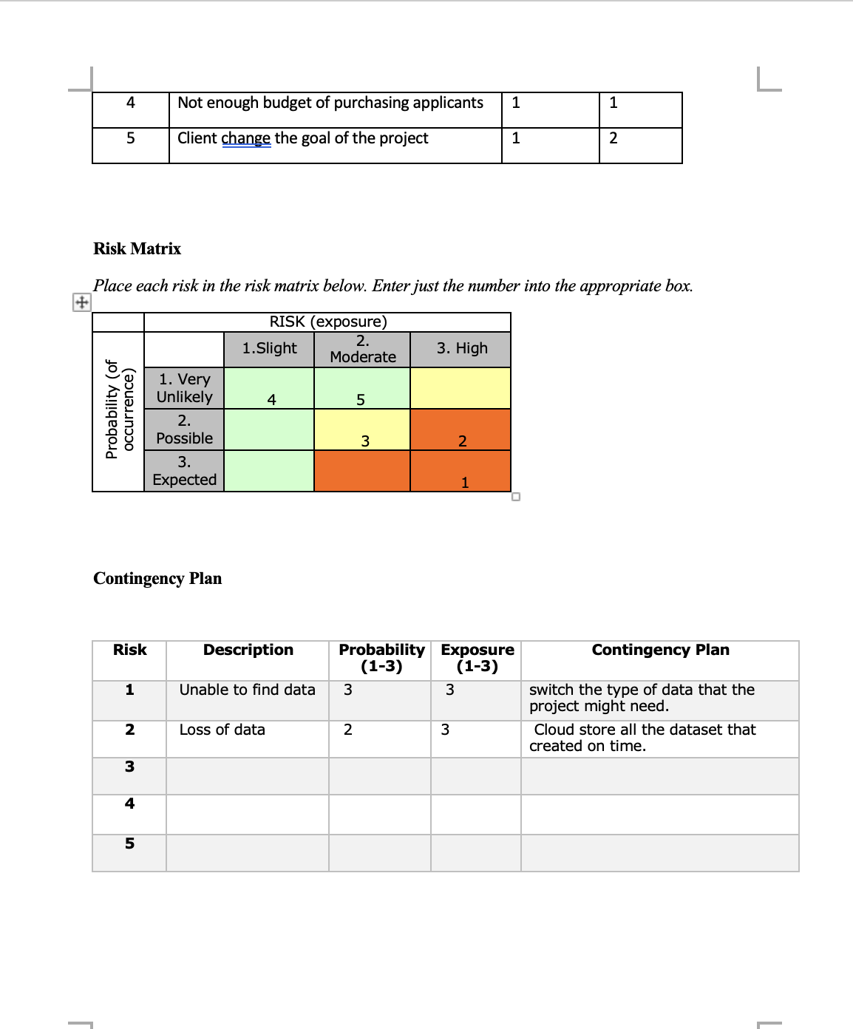

Figure 21: Risk Management Plan Page2.

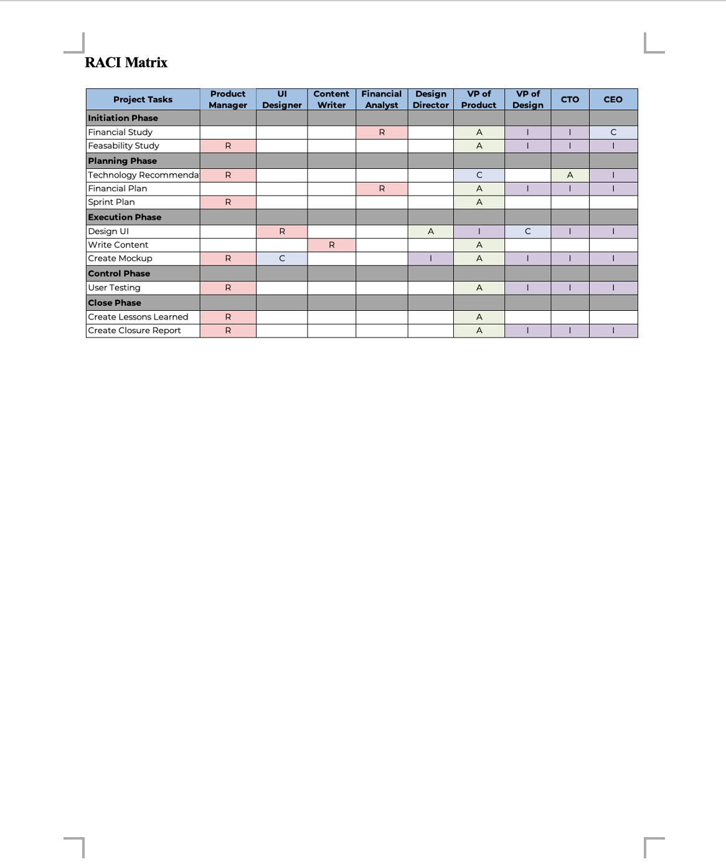

Figure 22: Risk Management Plan Page3.

# Appendix F - Status Report

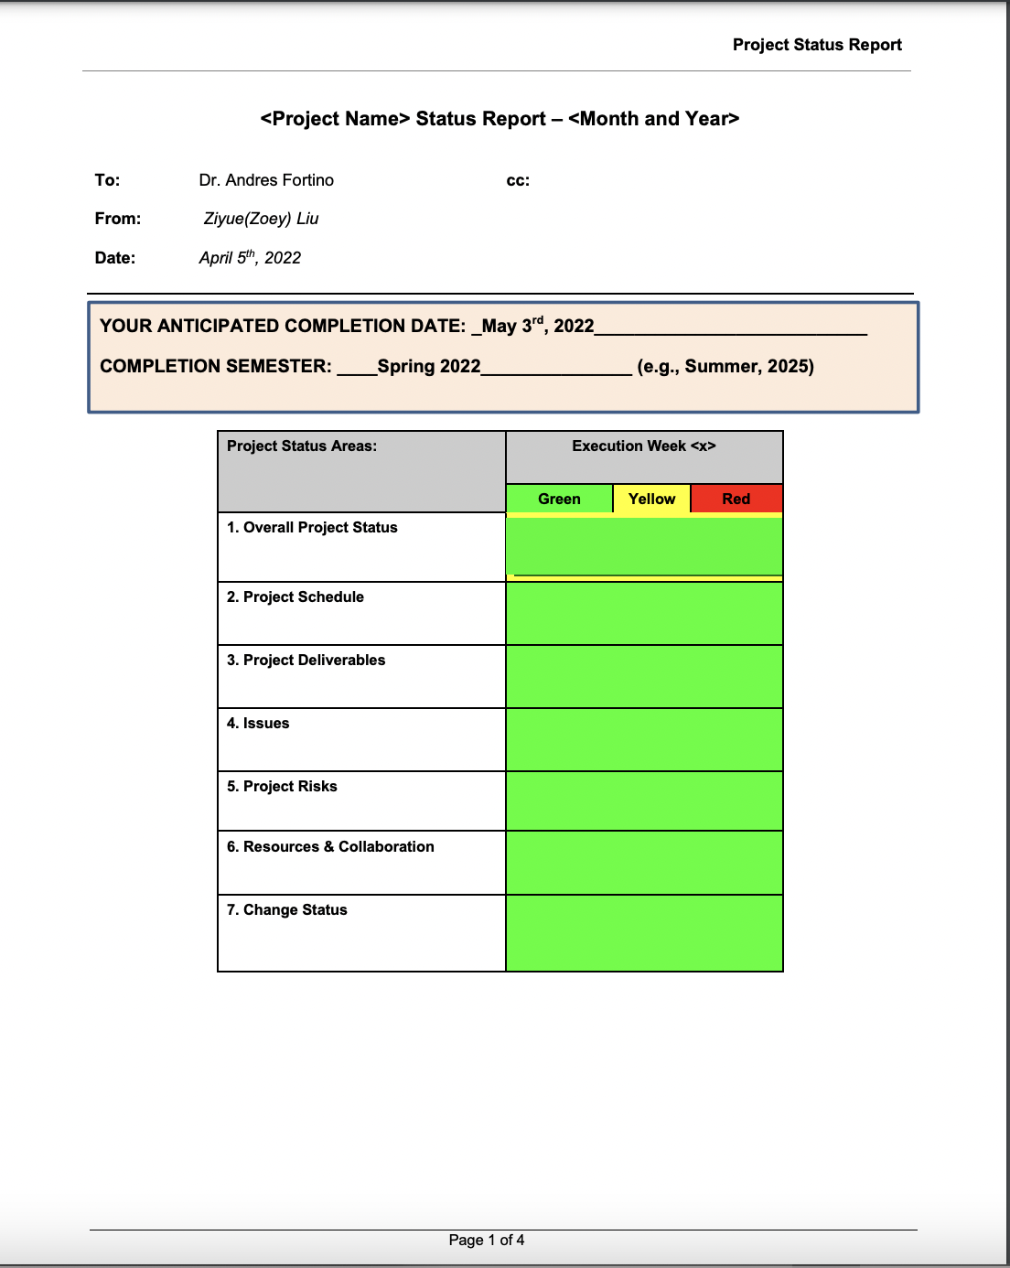

Figure 22: Status Report Page 1.

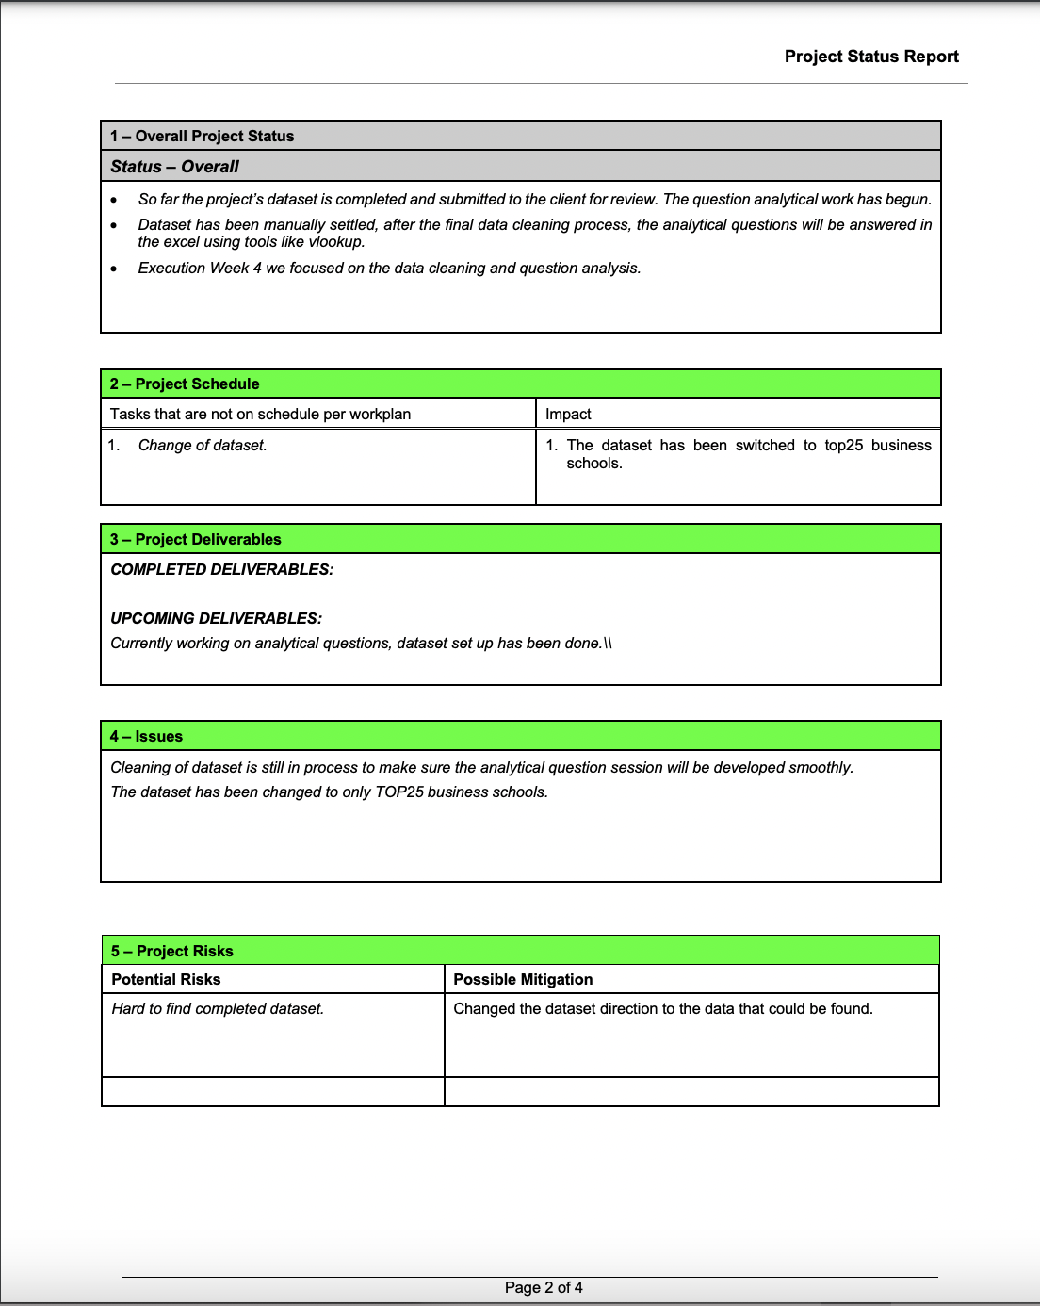

Figure 23: Status Report Page 2.

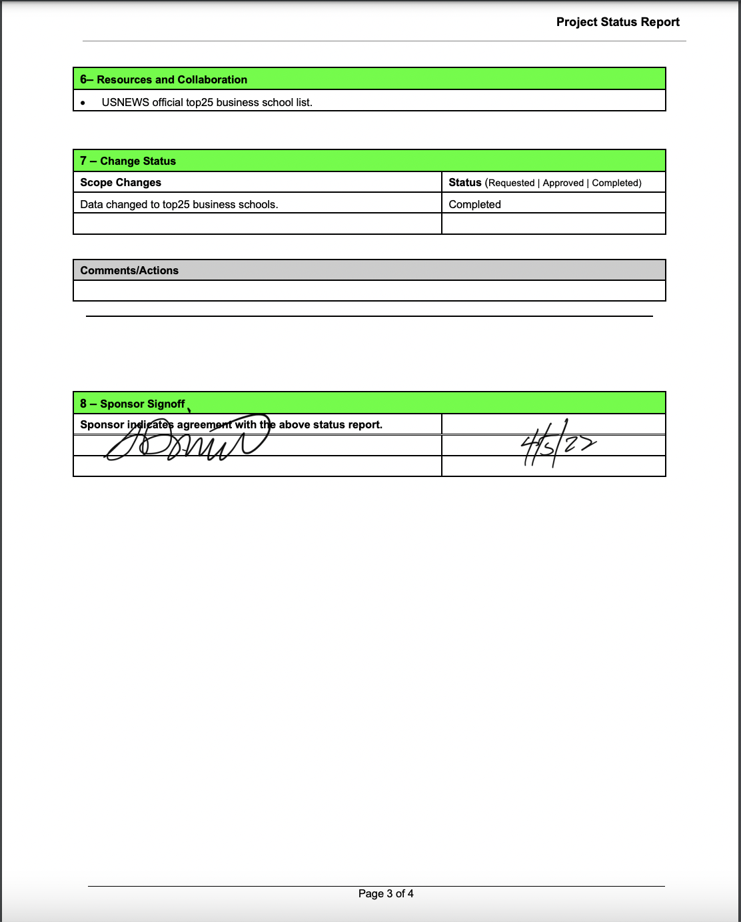

Figure 24: Status Report Page 3.

# Appendix G - Annotated Bibliography

1. Arpan, L. M., Raney, A. A., & Zivnuska, S. (2003). A cognitive approach to understanding university image. *Corporate Communications: An International Journal*, *8*(2), 97–113. https://doi.org/10.1108/1356328031047535

*Abstract*

This study employed a cognitive psychological approach to examining a little studied phenomenon – university image - among two groups of evaluators. The study found that different groups used different criteria when rating ten major US universities. Found to significantly predict the image of the universities among a sample of current university students were three factors: academic factors, athletic factors, and the extent of news coverage of the university. Found to significantly predict the image of the same universities among an adult, non-student. sample were four factors: a combined factor including all university attributes (including academic and athletic); the extent of news coverage; the education level of respondents; and the respondents' level of sports fan ship. Recent research in attitude structure is used to explain how different image criteria are recalled and employed by the different groups.

**This study is a study of university-image through psychological phenomena. Also, this research related to ranking of universities, which is really important element in my project. It includes an analysis of the academic content of the university and the curriculum arrangement, which will help me with the background aspect of the Structure of Professional Studies project.**

1. Brinkmann, J., Sims, R. R., & Nelson, L. J. (2011). Journal of Business Ethics Education. *Business Ethics across the Curriculum*, *8*, 83–104.

*Abstract*

This article describes and discusses team teaching and particularly guest lectures as a way of integrating ethics into the business curriculum. After a brief discussion of business school responsibilities and the teaching of ethics, the article looks at efforts to integrate the teaching of ethics across the curriculum. Then, findings from a small pilot study among business ethics and business school colleagues are summarized and discussed, with a focus on guest lecturing and team teaching, both with regard to experience and to faculty’s willingness to try. A final section of the article formulates recommendations for how our theory could be translated into practice

**This article focuses on the integration of morality, responsibility, ethics and business courses. The article includes a summary and discussion of some of the relevant research conducted in business schools. The integration of the teaching of ethics into the business curriculum is an improvement and innovation in the business school curriculum. Since my research has also been conducted on the content and programs of business schools, I think this study may be useful for my research.**

1. Chia, R., & Holt, R. (2008). The nature of knowledge in business schools. *Academy of Management Learning & Education*, *7*(4), 471–486. <https://doi.org/10.5465/amle.2008.35882188>

*Abstract*

We contribute to the debate on the future of business schools by investigating the nature of knowledge being produced and taught within them. We identify how a preference for abstract causal explanation over practical knowledge, and for reason and truth over what works, has led to a privileging of detached contemplation over involved action. Despite repeated calls to make management research and education more “relevant” to practice, many business schools continue to privilege rigor and precision as the arbiters of authoritative knowledge using representational devices such as conceptual models, case studies, and other formal classifications. We argue that risks of ignorance and detachment emerge from this singular attachment to knowledge-by-representation in business schools. We identify the need for an alternative, accompanying form of knowledge associated with the art of management that can only be transmitted through exemplary behavior within the business education process. We call this knowledge-by-exemplification: one that is demonstrative, creative and unreflectively performative, transmitted directly through the demeanor, style, and mannerism of management educators rather than through the content of lectures. For us, it is this relatively unnoticed aspect of the education process that provides one possible answer to the predicament of relevance facing business schools.

**This study examines the management and education of university’s business schools and provides an outlook on the future of business schools. Since the Structure of Professional Schools project is a study that compares business schools and professional schools, the study of business schools in this research will help my project to compare business schools and professional schools.**

1. Elman, C., & O'Rand, A. M. (2004). The race is to the swift: Socioeconomic origins, adult education, and wage attainment. *American Journal of Sociology*, **110**(1), 123– 160. <https://doi.org/10.1086/386273>

*Abstract*

The “winners” in today’s winner‐take‐all labor markets are differentiated by advanced levels of educational attainment, especially higher degrees. This article applies a sociological model of cumulative dis/advantage to the baby‐boom cohort to examine whether life course timing differences in educational attainment help explain wage differentials by midlife. It finds that advantaged social origins lead to early postsecondary completion of degrees, which, in turn, yield higher wages. A pathway of cumulative disadvantage is also evident, where those least advantaged exit schooling early in life, do not return as adults, and earn low wages. In a middle path, advantaged social origins promote adult school attainment primarily for those without degrees but generally without the wage boosts associated with attainment earlier in life.

**This article compares the effects of educational attainment on wage differences and degree levels through a sociological model. The analysis is whether a higher degree leads to a higher level of wages. Since my project is studying higher education, many people go on to graduate business school or vocational school to get higher wages, and the findings of this article can help my project compare the effects of graduate school and higher degrees on student choice.**

1. Fortino, Andres (2022). The Role of Schools of Professional Studies in Management Education. Proposal for a Professional Development Workshop to be presented at The Academy of Management Annual Meeting.

*Abstract*

There has been a major debate for over 50 years within traditional business and management schools as to their acceptance or rejection of professional schools and professional managers, and sole focus on academics. Many AOM members are a product of that tradition and are currently researching and teaching from that mindset. For those of us in non-traditional schools such Schools of Professional Studies, we offer how we add value with any management education, especially in the shadow of an influential business school within the same university, backed by the AACSB. The Business School teaches marketing; Schools of Professional Studies teach marketing, for example. The Business School teaches finance; Schools of Professional Studies teach finance. So then what is the role of the School of Professional Studies (SPS) in management education? Does SPS compete with or complement the business school? How far along the academic scale should Schools of Professional Studies aim? How much emphasis on practical industry expertise should be applied? How can SPS balance all of these forces and add value to the student and future employer? This PDW invites participants to articulate and clarify this role and to contribute to creating a clear set of principles to guide Schools of Professional Studies in their management education offerings.

**This article raises very critical questions: what is the role of SPS in management education and do SPS and business schools compete or complement each other?. These are the main questions that my project is looking for. By conducting a study of the curriculum, majors, and programs of business schools and SPS at Top 25 universities, I will analyze what is the most fundamental relationship between business schools and SPS.**

1. Holtzman, S., Minott, T., Devasia, N., Kirova, D., & Klieger, D. (2021). Exploring diversity in graduate and Professional School Applications. *ETS Research Report Series*, *2021*(1), 1–19. <https://doi.org/10.1002/ets2.12330>

*Abstract*

Gathering a diverse student body is important for institutions of higher education (IHEs) at the graduate/professional level. However, it is impossible to select a diverse student body from a homogenous group of candidates. Thus, the aim of this study is to discover the extent to which diversity goals in admissions are precluded by the lack of diversity in the applicant pool. To explore this, the proportion of score reports sent to the 150 largest graduate/professional schools and sent for each major was compared, from each gender, race, and socioeconomic status (SES) grouping, to proportions from the overall applicant pool of graduate/professional students. Additionally, differences in the distance graduate/professional school applicants are willing to consider traveling by gender, race/ethnicity, and SES were investigated. Results show that differences exist in the gender, race, and SES distributions for score reports sent to different schools and for different majors as well as in the distance an applicant is willing to consider traveling for graduate/professional school. The patterns found for gender, racial, and socioeconomic diversity provide possibilities for researchers to work further together with graduate/professional schools to tackle the important challenge of increasing diversity in graduate/professional education.

**Although this study compares admissions information for graduate degrees at universities, it provides a wealth of basic information about graduate and professional schools, which is useful for background information on the program. It’s also support my project with some professional terms like SES, IHEs, these became the advice or ideas when I do my research.**

1. Maringe, F. (2006). University and course choice. *International Journal of Educational Management*, *20*(6), 466–479. https://doi.org/10.1108/09513540610683711

*Abstract*

Higher education environments have become increasingly competitive and institutions have to compete for students in the recruitment markets. With the introduction of student fees, it is hypothesised that potential applicants to HE will increasingly become consumerist. The research upon which this paper was based was aimed at finding out the factors students consider important in their decision making related to choice of university and courses of study.

**This study analyzes and examines the decisions that students make when choosing an institution, and it shows how some institutions of higher education have changed their curriculum and the majors they offer to compete for the best students. For my project, I was given background information about the institution.**

1. Murillo, D., & Vallentin, S. (2015). The Business School’s right to operate: Responsibilization and resistance. *Journal of Business Ethics*, *136*(4), 743–757. <https://doi.org/10.1007/s10551-015-2872-1>

*Abstract*

The current crisis has come at a cost not only for big business but also for business schools. Business schools have been deemed largely responsible for developing and teaching socially dysfunctional curricula that, if anything, has served to promote and accelerate the kind of ruthless behavior and lack of self-restraint and social irresponsibility among top executives that have been seen as causing the crisis. As a result, many calls have been made for business schools to accept their responsibilities as social institutions and to work toward becoming more socially embedded and better attuned to public interests. In this paper, however, we point to some of the barriers there may be in the way of business schools developing into responsible organizational citizens proper. We argue that there are lines of resistance against responsibilization operating at epistemological, institutional, and organization levels and that we need to take account of barriers on all these levels in order to properly capture the challenges that are involved in making the modern business school amenable to demands for more social responsibility. In terms of working toward overcoming such barriers, we discuss how business education can become more socially embedded via the inclusion of ethical reflection and critical thinking.

**This article analyzes not only the current crisis faced by business schools, but also the crisis faced by some companies in the market and the costs they pay. Because of the inseparable relationship between business schools and society and the market, this article makes it possible to have a better supporting theory for the study of business schools. It makes the research content more convincing.**

1. Vargo, S. L., & Lusch, R. F. (2004). Evolving to a new dominant logic for marketing. *Journal of Marketing*, *68*(1), 1–17. <https://doi.org/10.1509/jmkg.68.1.1.24036>

*Abstract*

Marketing inherited a model of exchange from economics, which had a dominant logic based on the exchange of “goods,” which usually are manufactured output. The dominant logic focused on tangible resources, embedded value, and transactions. Over the past several decades, new perspectives have emerged that have a revised logic focused on intangible resources, the cocreation of value, and relationships. The authors believe that the new perspectives are converging to form a new dominant logic for marketing, one in which service provision rather than goods is fundamental to economic exchange. The authors explore this evolving logic and the corresponding shift in perspective for marketing scholars, marketing practitioners, and marketing educators.

**Since my project is to study the comparison and research of business schools and professional schools in terms of professional fields and curriculum, the economic thinking of this article can be well used to analyze the business concepts of business schools and professional schools. The economics of this article can be used to analyze the business philosophy of business schools and professional schools. The pros and cons of continuing education are analyzed from a business perspective. This makes my research not only limited to the curriculum, but also deeper into why it is set according to the current business context.**

1. Usdiken, B., Kipping, M., & Engwall, L. (2021). PROFESSIONAL SCHOOL OBSESSION: AN ENDURING YET SHIFTING RHETORIC BY US BUSINESS SCHOOLS. *Academy of Management Learning & Education*, (ja).

*Abstract*

Over the past two decades, prompted in part by a series of corporate scandals, different views have been voiced about why U.S. business schools have purportedly lost their original ambition to become professional schools and, thus, to make management a“true”profession, and how this ambition could be restored. This paper puts these debates into a longer-term perspective by showing that such claims have been present for more than a century.The paper examines the evolving rhetoric of the protagonists and their critics over five periods, each marked by different contexts, which shaped the ambitions of schools of business to be recognized as professional schools. These claims, the paper shows, had a common thread for over 100 years, which was the recurring reference to other professional schools—namely those of medicine and law, and at times engineering, which had already achieved the coveted status when U.S. business schools first originated. We ultimately argue that, given the rhetorical nature of these claims, suggestions that business schoolslost their way or ought to return to some idealized past are largely futile. Future discussions should therefore focus on purpose and power rather than profession.

**This article analyzes the development of business schools in the context of historical scandals. It provides a longer-term perspective on how business schools can be restored to their original purpose as professional schools. Because this article includes the perspectives of different critics from five periods, years of background information, and different perspectives from multiple schools, it provides considerable background knowledge to support my research. It allowed me to conduct more detailed research and information gathering with a better understanding of business schools and vocational schools.**